Exercise: Android Resource, Menu and Intent
Document Number: |  | Issue Number:  Date:

TABLE OF CONTENTS
1 Exercise 1: Create a very simple Android application with Resource 2
1.1 Description 2
1.2 Create new Android application with Resource. 2
2 Exercise 2: Create new Android application with Menu (Android 2.2 and before) 5
2.1 Description 5
2.2 Create new Android application with Menu 5
3 Exercise 3: Create new Android application with ActionBar 10
3.1 Description 10
3.2 Create new Android application with ActionBar 10
4 Exercise 4: Create new Android application with Intent 18
4.1 Description 18
4.2 Create new Android application with Intent 18

Exercise 1: Create a very simple Android application with Resource

Description
The purpose of this exercise is let student understand how to work with Resource. At the end of this exercise they can create a very simple application which will use some kinds of Resource.

Create new Android application with Resource.
In Eclipse, go to File -> New - >Others
Choose Android -> Android Application Project.
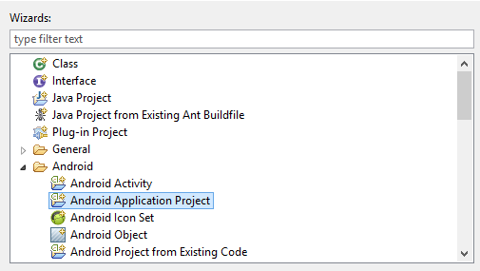
Name Application Name: ResourceExercise and press Next.
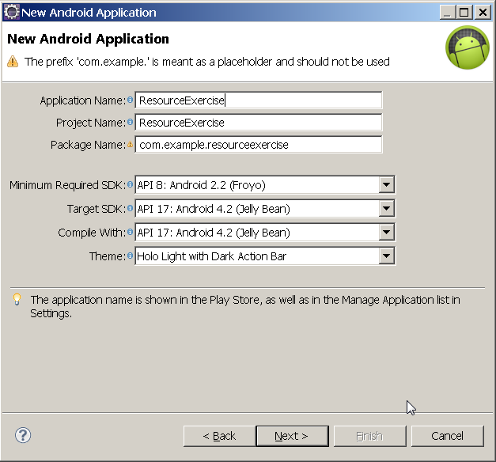
Continue to press Next until Finish is highlighted.
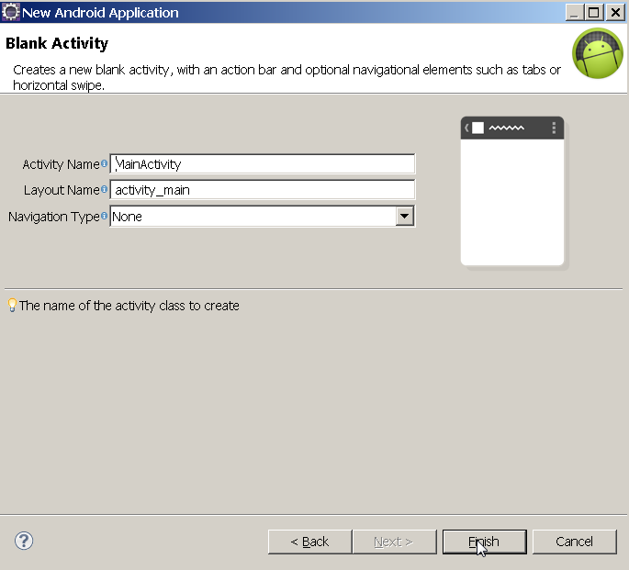
Click Finish.
Open string resource file in res/values/strings.xml, add new string resource name text_resource:
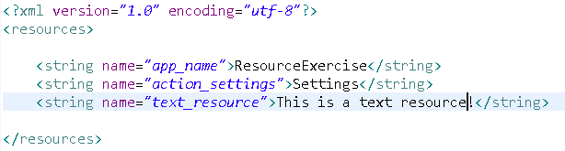
In GUI designer, double click to let it expands full screen.
Add the Text View to layout and edit it to use the text Resource:
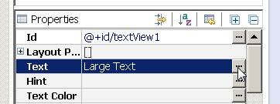
Select text_resource:
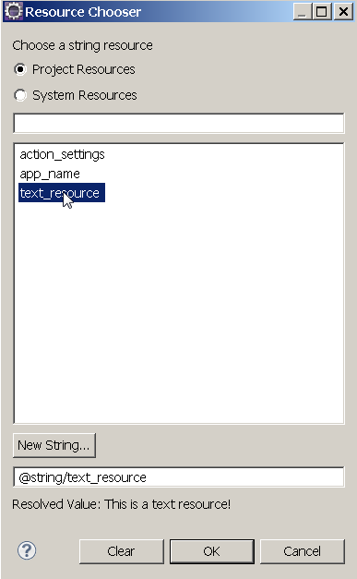
It is showed in the GUI:
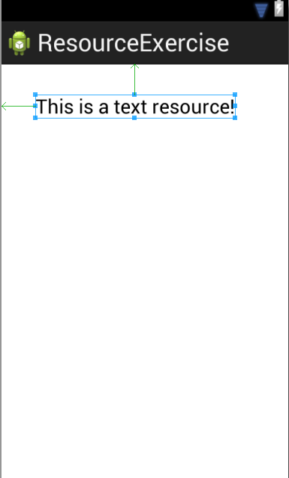

Exercise 2: Create new Android application with Menu (Android 2.2 and before)

Description
The purpose of this exercise is let student understand how to work with Menu in Android version 2.2 and before. At the end of this exercise they can create a very simple application which will have simple menu.

Create new Android application with Menu
Create new Android Application name Menu22Exercise:
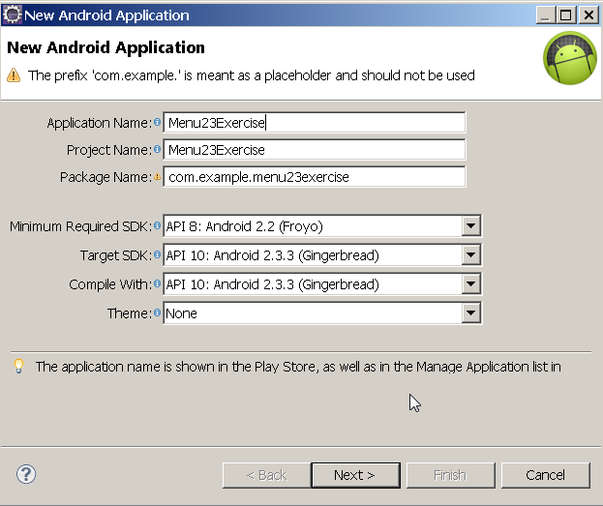
Keep the default GUI, we will create the menu layout.
Right click on menu folder, choose New -> Android XML File:
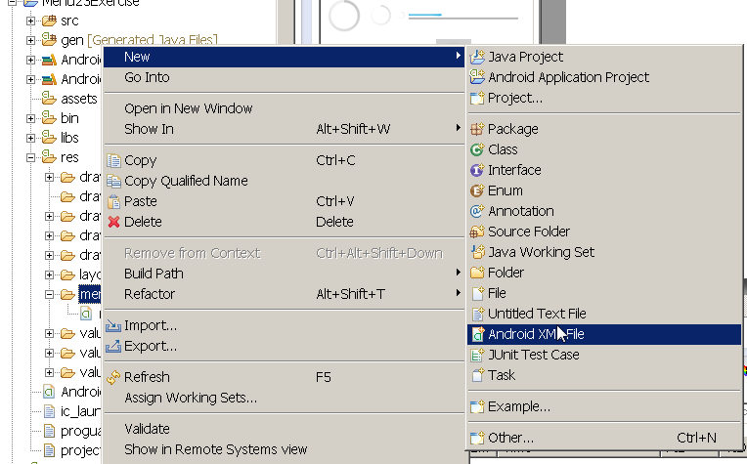
Name it menu23exercise and click Finish:
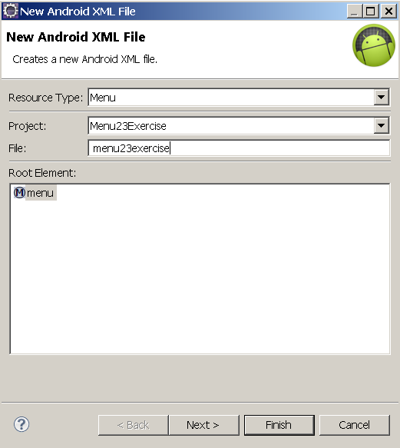
Open the newly created file:
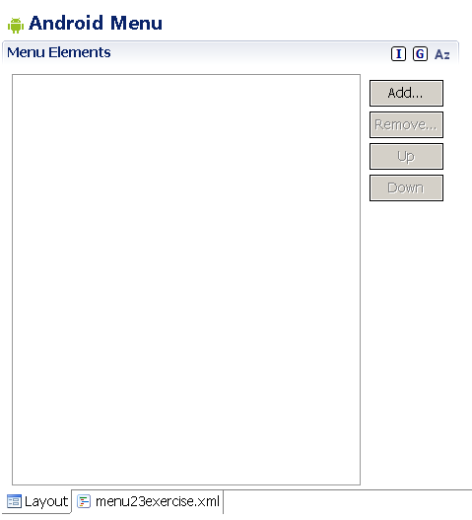
Click Add button and add menu items:
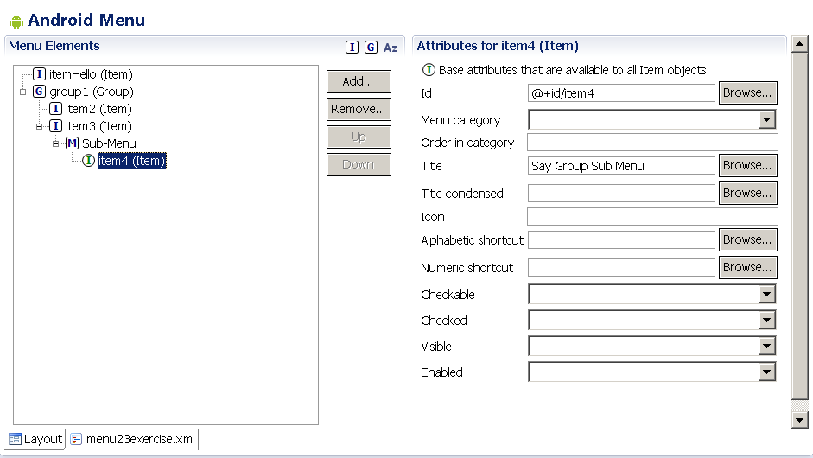
Open MainActivity source file and add code:
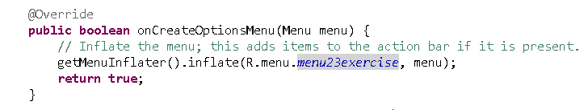
We also need to handle the event when user clicks on the menu:
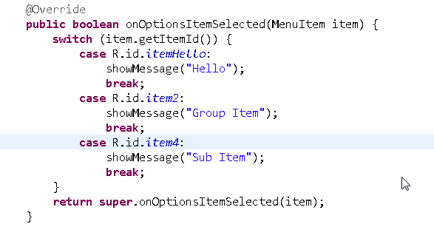
Add showMessage() method to MainActivity:
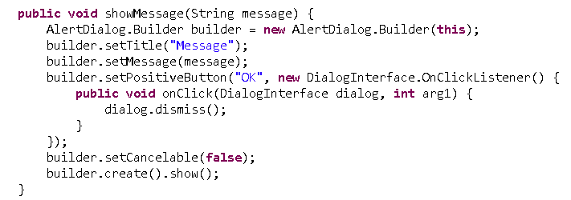
Right click on Menu23Exercise, choose Run -> Android Application.
Switch to the emulator and click Menu button:
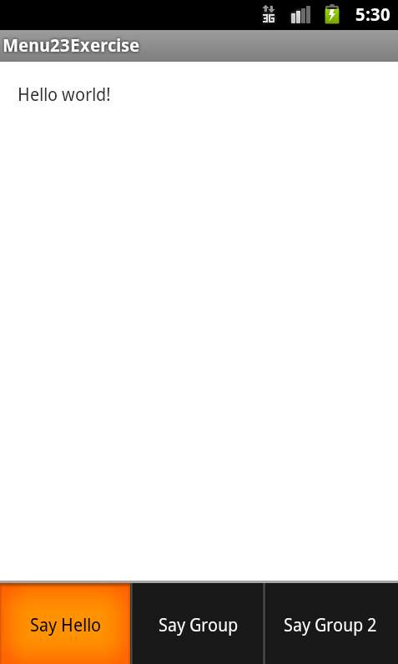
Click on “Say Hello”:
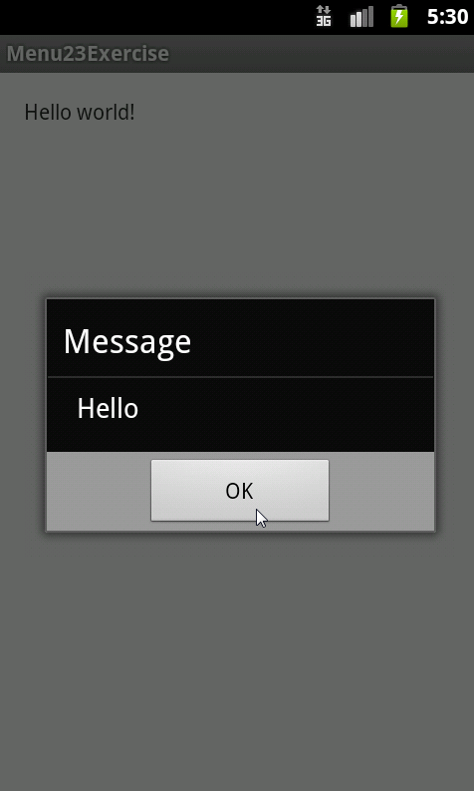
Open the menu again and click on Say Group 2:
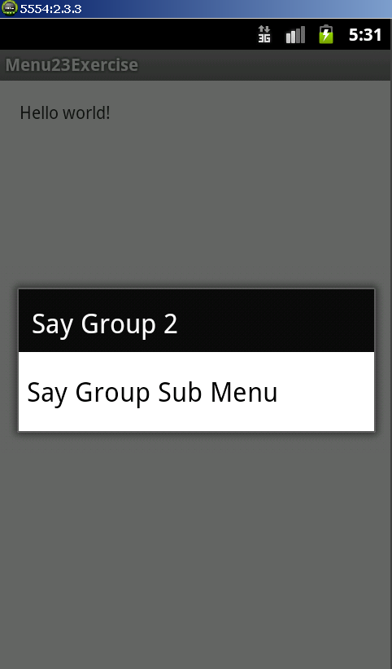
Click on Say Group Sub Menu:
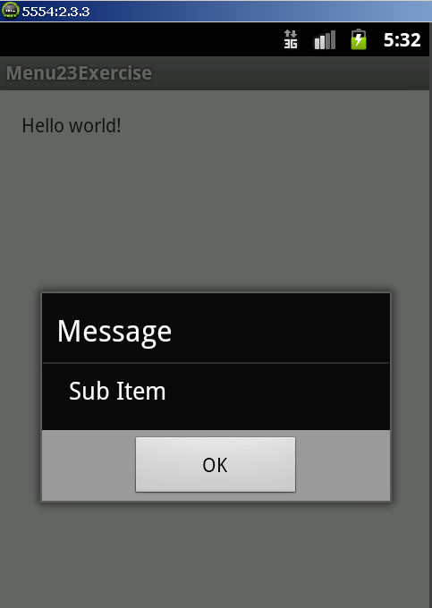
Congratulation! You have completed the second exercise.

Exercise 3: Create new Android application with ActionBar

Description
The purpose of this exercise is let student understand how to work with Action Bar. At the end of this exercise they can create a very simple application which will use Action Bar.

Create new Android application with ActionBar
Create new Android Application name ActionBarExercise:
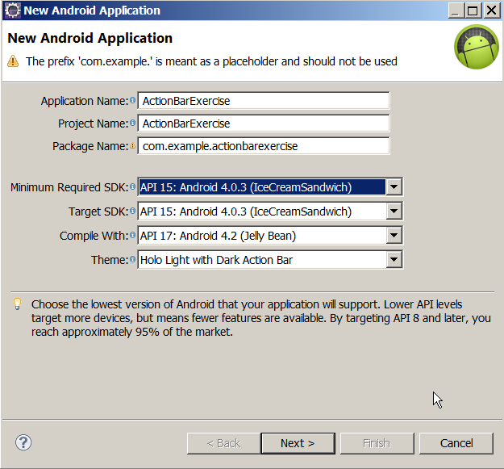

Open file menu/main.xml and change the code to:
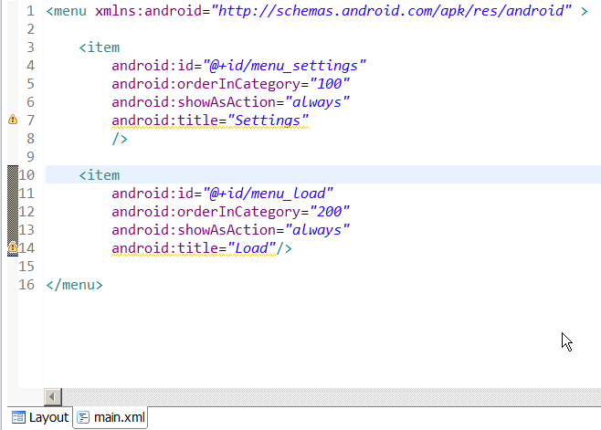
Open class MainActivity and add code to add ActionBar:
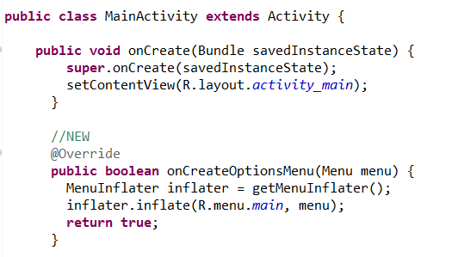
Add code to handle ActionBar event:
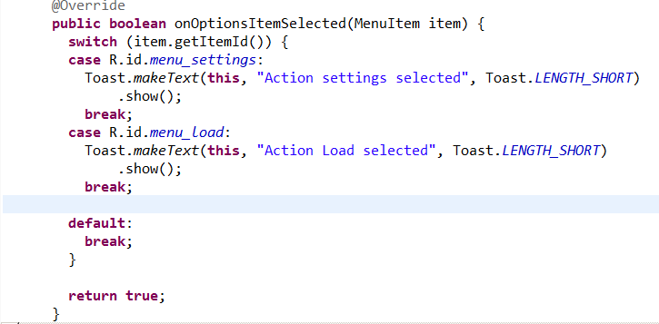
Right click on the application and choose Run:
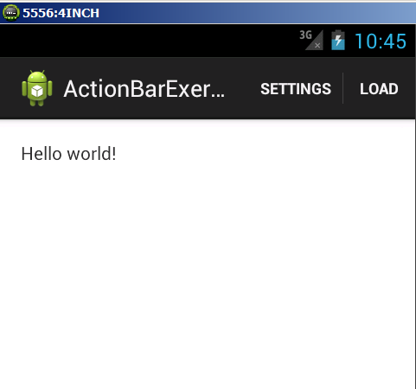
Click on Settings:
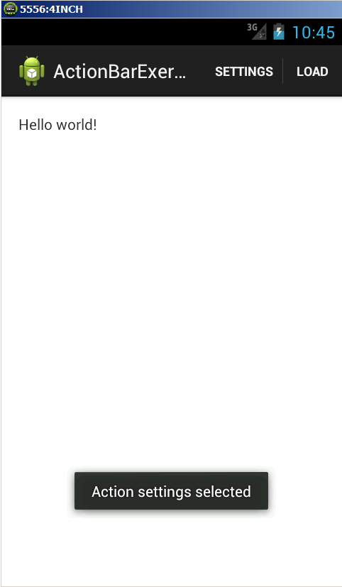
Click on Load:
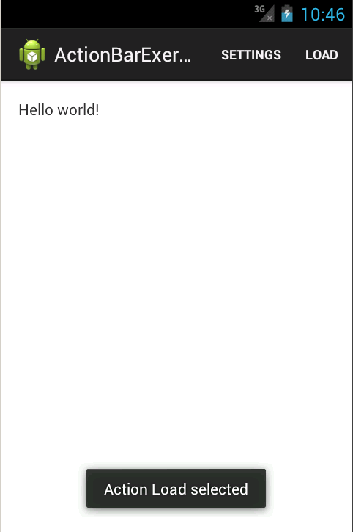
Go back to MainActivity layout and add a new edit text:
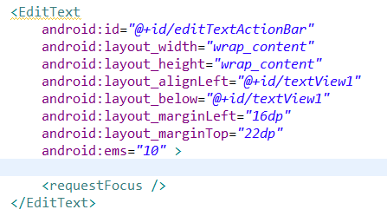
Create a new menu XML resource with the contextaction.xml file name:
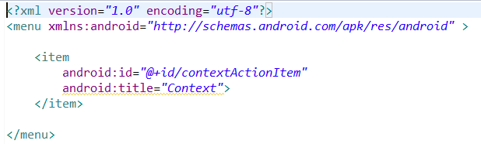
Go to MainActivity onCreate method and change the source to:
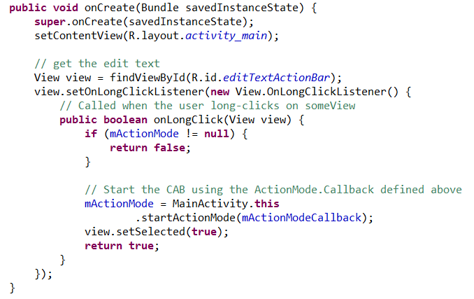
Add mActionModeCallback to MainActivity:
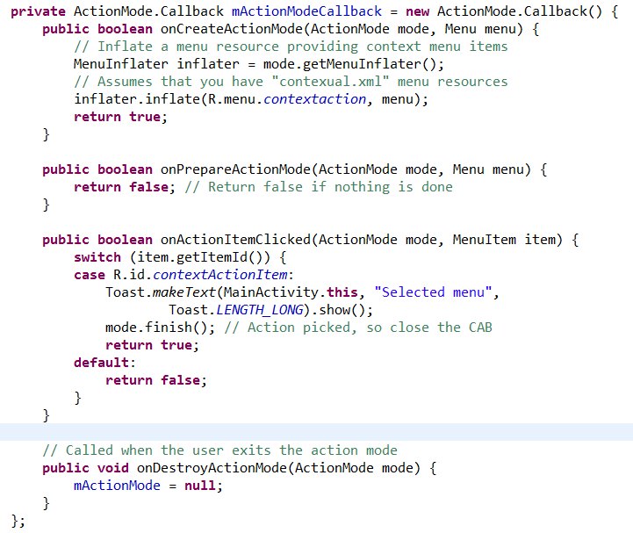
Run the application again:
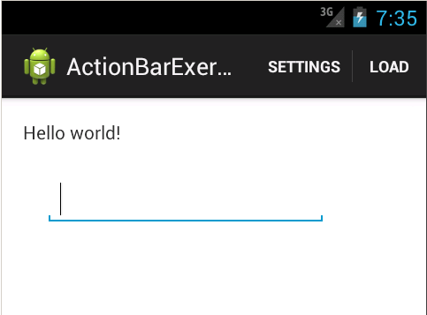
Click and hold at the edit text so the context action bar is showed:
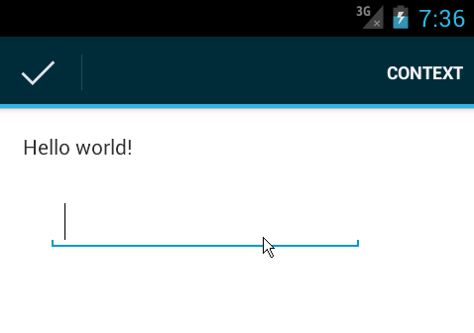
Click on the button Context:
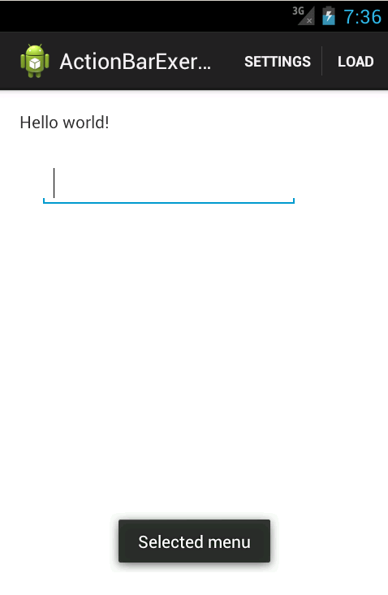

Now go back to MainActivity layout and add button called “Context”:
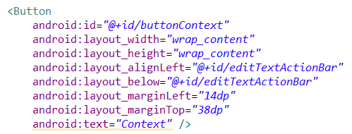
Create new menu XML file called screen_context_menu.xml:
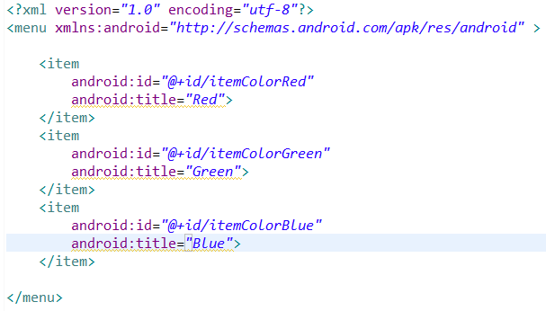
Go to MainActivity source code and add this line to onCreate method:
Add two more methods to MainActivity:
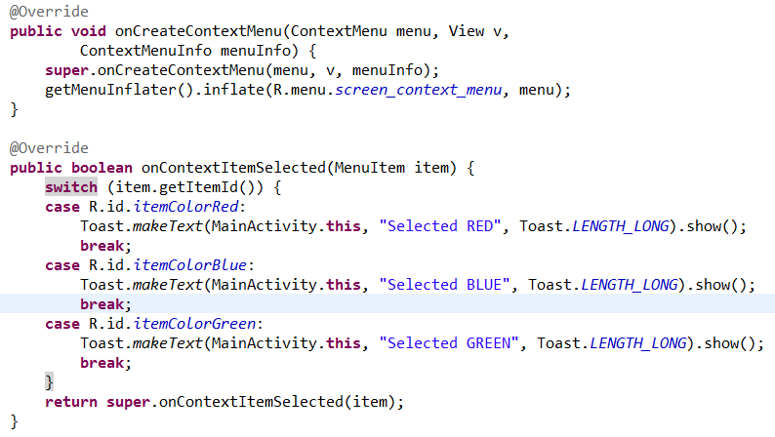
Run the application again:
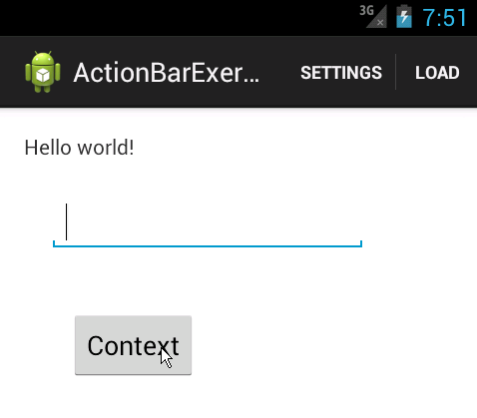
Click and hold Context button:
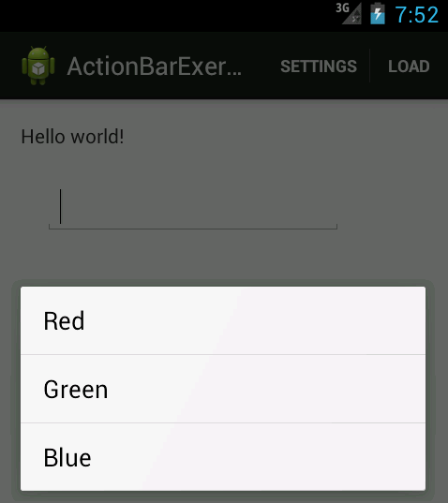
Choose any of the option in the menu and the screen will display the message:
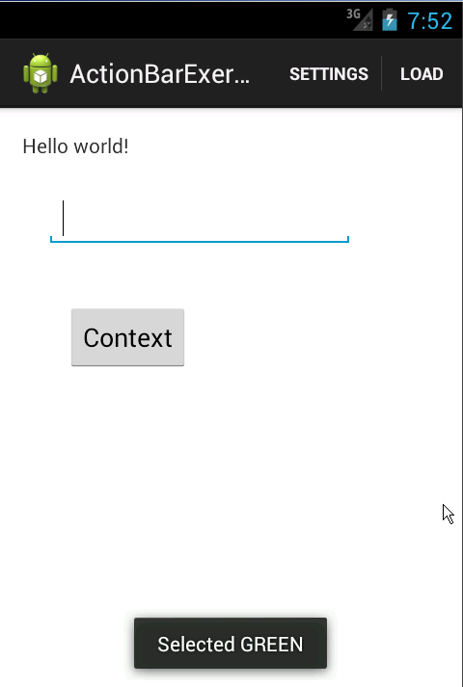
Congratulation! You have finished the third exercise.

Exercise 4: Create new Android application with Intent

Description
The purpose of this exercise is let student understand how to work with Intent. At the end of this exercise they can create a very simple application which will use Intent.

Create new Android application with Intent
Create new Android Application name:
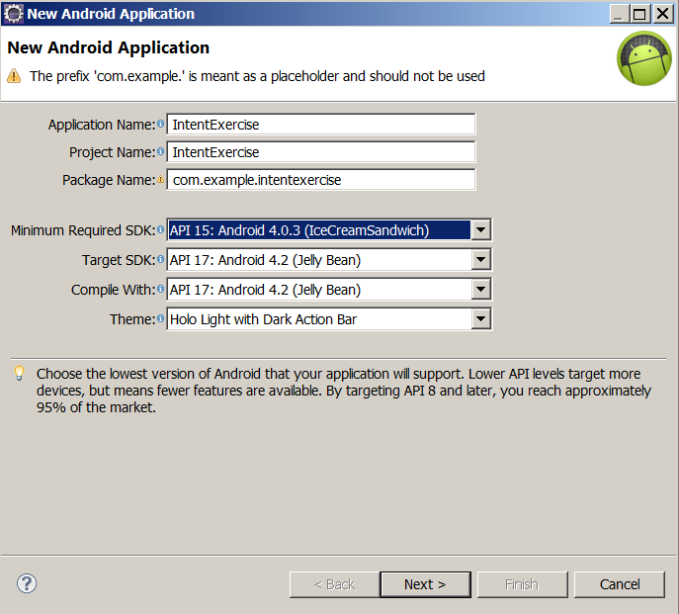
Continue to press Next until Finish is highlighted.
Create another activity called CalculateActivity:
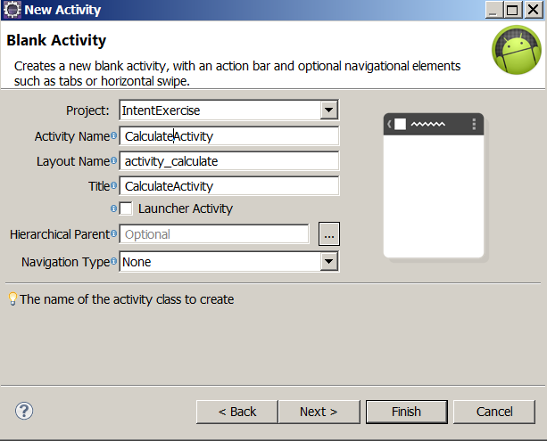
In GUI designer, double click to let it expands full screen.
Build the GUI of MainActivity so it looks like this:
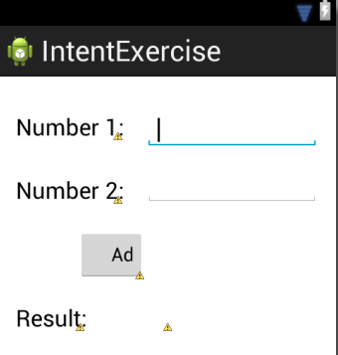
Build the GUI of the CalculateActivity so it looks like this:
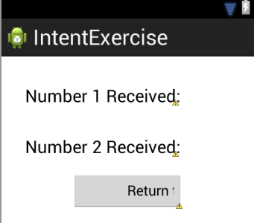
Change the code of the MainActivity to use Intent:
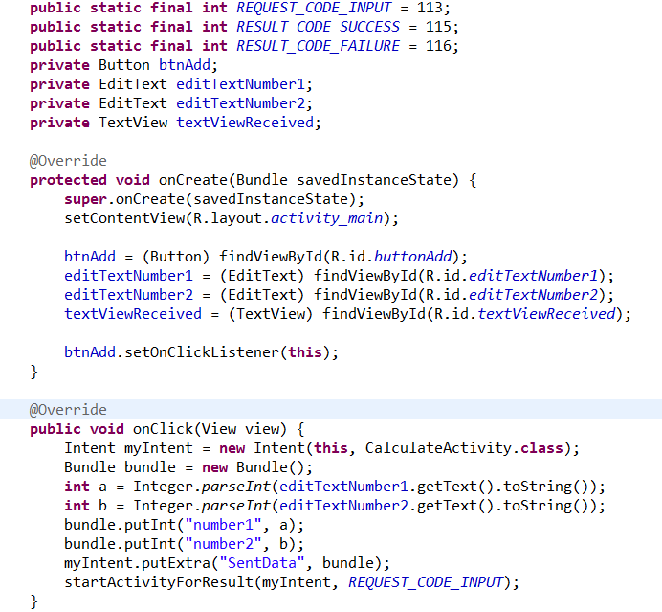
Get result from other Activity:
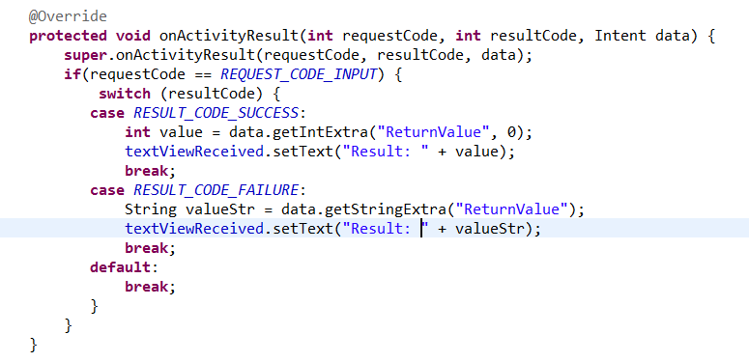
Change the code of CalculateActivity to receive the Intent:
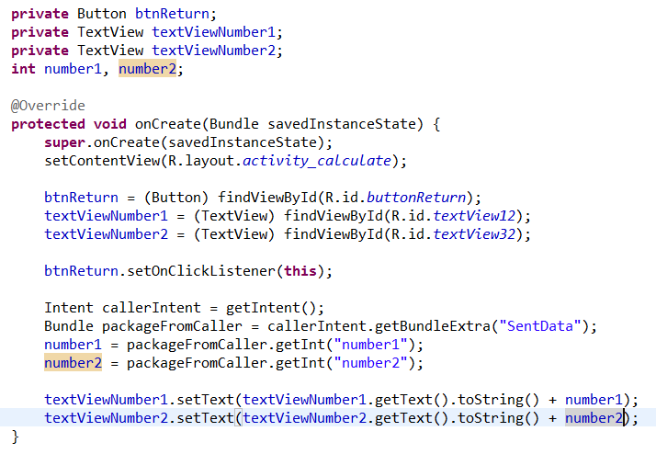
And return the result to caller Activity:
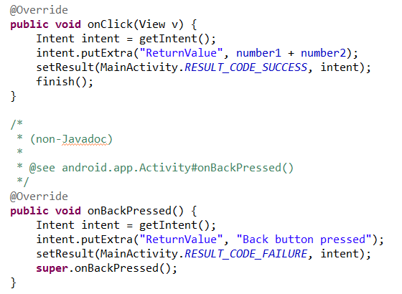
Run the application:
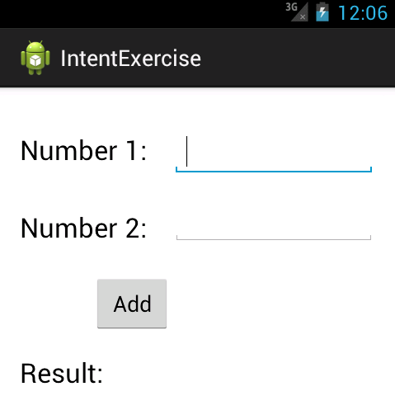
Input the number:
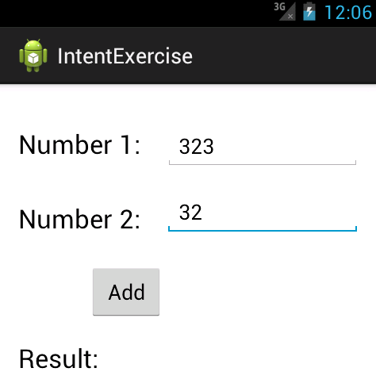
Click Add button, the CalculateActivity will be showed:
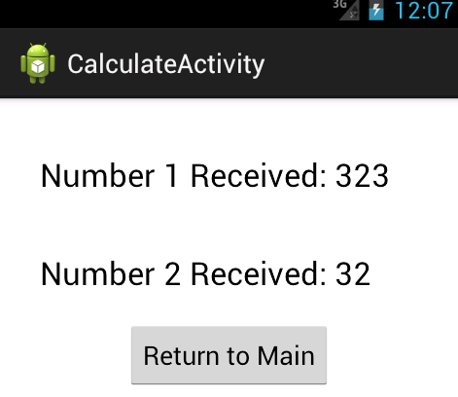
Click Return to Main, the Result will be showed:
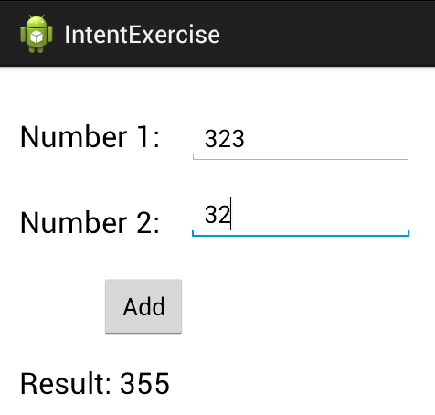
Now click Add again:
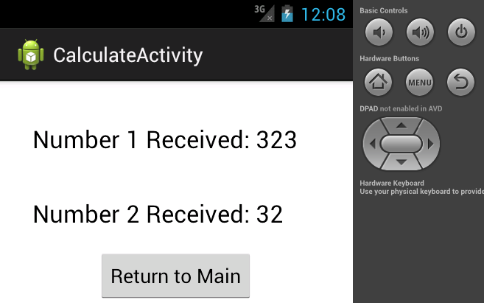
Click back button:
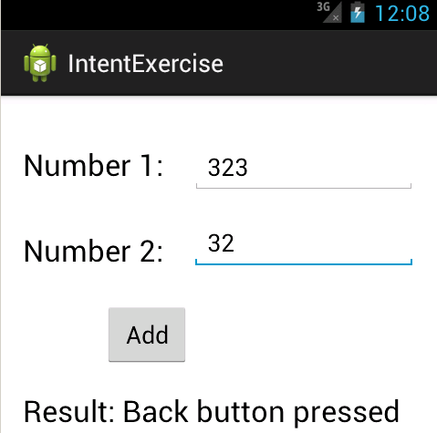
Congratulation! You have finished the forth exercise.

